Comparative Analysis of Hybrid Models of AES-RSA and AES-Triple DES Algorithms for Encryption of Images and Videos

A Thesis Submitted to

Chhattisgarh Swami Vivekanand Technical University, Bhilai (C.G.), India
In partial fulfillment for the award of the degree of
Bachelor of Technology
In
Computer Science and Engineering
by
Varun Maharana
(University Roll No: 309302220094 , Enrollment No: BJ2340)
J Kirti Rao
(University Roll No: 309302220040 , Enrollment No: BJ2021)
Harsh Chandrakar
(University Roll No: 309302220027 , Enrollment No: BJ1999)
Simran Dey Biswas
(University Roll No: 309302220098 , Enrollment No: BJ4952)
Under the Guidance
of
LALITA PANIKA
(Assistant Professor, Department of Computer Science and Engineering)
Bhilai Institute of Technology, Kendri , Raipur
Session : 2020 - 2024
I
Declaration by the Candidate

We solemnly declare that the report of the thesis work entitled “Comparative Analysis of Hybrid Models of AES-RSA and AES-Triple DES Algorithms for Encryption of Images and Videos” is based on our own work carried out during the course of our study under the supervision of Prof. Lalita Panika.
We assert that the statements made and conclusions drawn are an outcome of the project work. We further declare that to the best of our knowledge and belief that the report does not contain any part of any work which has been submitted for the award of any other degree/diploma/certificate in this University/deemed University of India or any other country. All help received and citations used for the preparation of the thesis have been duly acknowledged.

__________________ __________________
Name of the candidate: Varun Maharana Name of the candidate: J Kirti Rao
Roll No.: 309302220094 Roll No.: 309302220040
Enrollment No.: BJ2340 Enrollment No.: BJ2021

____________________ __________________
Name of the candidate: Harsh Chandrakar Name of the candidate: Simran Dey Biswas
Roll No.: 309302220027 Roll No.: 309302220098
Enrollment No.: BJ1999 Enrollment No.: BJ4952

II
Certificate of the Supervisor

This is to certify that the report of the thesis entitled “Comparative Analysis of Hybrid Models of AES-RSA and AES-Triple DES Algorithms for Encryption of Images and Videos”, is a record of Bonafide research work carried out by Varun Maharana (Roll no: 309302220094, Enrollment No: BJ2340), J Kirti Rao (Roll no: 309302220040, Enrollment No: BJ2021), Harsh Chandrakar (Roll no: 309302220027, Enrollment No: BJ1999), Simran Dey Biswas (Roll no: 309302220098, Enrollment No: BJ4952), under my guidance and supervision for the award of Degree of Bachelor of Technology in the faculty of Computer Science and Engineering, of Chhattisgarh Swami Vivekanand Technical University, Bhilai (C.G.), India. To the best of my knowledge and belief the thesis.
- Embodies the work of the candidate him/herself,
- Has duly been completed,
- Fulfills the requirement of the ordinance relating to the B.Tech degree of the University and is up to the desired standard both in respect of contents and language for being referred to the examiners.

______________________ ______________________
(Signature of the supervisor) (Signature of the HOD)
Lalita Panika Omprakash Barapatre
Assistant Professor Head of Department
Computer Science and Engineering Computer Science and Engineering
Bhilai Institute of Technology, Raipur Bhilai Institute of Technology, Raipur

Forwarded to Chhattisgarh Swami Vivekanand Technical University, Bhilai

________________________

(Signature of the Director/Principal)
Bhilai Institute of Technology , Kendri , Raipur

III

Certificate by the Examiner

The Thesis entitled “Comparative Analysis of Hybrid Models of AES-RSA and AES-Triple DES Algorithms for Encryption of Images and Videos” by Varun Maharana (Roll no: 309302220094, Enrollment No: BJ2340), J Kirti Rao (Roll no: 309302220040, Enrollment No: BJ2021), Harsh Chandrakar (Roll no: 309302220027, Enrollment No: BJ1999), Simran Dey Biswas (Roll no: 309302220098, Enrollment No: BJ4952), has been examined by the undersigned as a part of the examination and is hereby recommended for the award of the degree of Bachelor of Technology in the faculty of Computer Science and Engineering of Chhattisgarh Swami Vivekanand Technical University, Bhilai.

__________________ __________________
(Internal Examiner) (External Examiner)
Date: Date:

IV

ACKNOWLEDGEMENT

We pay our sincere thanks to our project guide Prof. Lalita Panika. We sincerely thank her for her numerous suggestions and commend her patience. It was an honor to have her as our project guide.
We would like to thank Prof. Aparna Pandey (Project Coordinator) for her kind and supportive attitude throughout the project.
We are highly thankful to Prof. Om Prakash Barapatre (Head of Department, Computer Science & Engineering), for providing us the necessary facilities and co-operation during the course of study.
We express our indebtedness to our Principal Dr. R. K. Mishra for the constant encouragement given throughout the project work. There are many people who have helped and supported us and we would like to take this opportunity to thank everyone.

Name of the candidate: Varun Maharana Name of the candidate: J Kirti Rao
Roll No. : 309302220094 Roll No. : 309302220040
Enrollment No.: BJ2340 Enrollment No.: BJ2021

Name of the candidate: Harsh Chandrakar Name of the candidate: Simran Dey Biswas
Roll No. : 309302220027 Roll No. : 309302220098
Enrollment No.: BJ1999 Enrollment No.: BJ4952

V
ABSTRACT

This study delves into a thorough comparative analysis of hybrid encryption models, leveraging the Advanced Encryption Standard (AES) in conjunction with both the Rivest-Shamir-Adleman (RSA) and Triple Data Encryption Standard (DES) algorithms, aimed at fortifying the security of multimedia content such as images and videos. By blending symmetric and asymmetric encryption techniques, these hybrid schemes endeavor to enhance data security while mitigating computational overhead. Through a meticulously designed experimental framework encompassing diverse datasets, encompassing a spectrum of performance metrics including encryption/decryption speed, security strength, and resilience against common cyber threats, the research scrutinizes the effectiveness and efficiency of AES-RSA and AES-Triple DES hybrid encryption models. Furthermore, the study delves into the practical viability of these hybrid schemes in real-world scenarios, factoring in considerations such as computational resource requirements, scalability, and compatibility with existing systems. The culmination of this endeavor is a comprehensive elucidation of the comparative advantages and limitations of the proposed hybrid encryption approaches, furnishing valuable insights to practitioners and researchers operating in the realms of cybersecurity and multimedia communication. Ultimately, the findings aim to offer informed guidance for selecting the most apt encryption methodology to safeguard multimedia content across a spectrum of applications and environments.

Keywords : Hybrid encryption, AES-RSA, AES-Triple DES, Multimedia security, Comparative analysis
.

TABLE OF CONTENTS
Declaration by the Candidate I
Certificate of the Supervisor II
Certificate by the Examiners III
Acknowledgment IV
Abstract V
List of Tables VI
List of Figures VII
List of Abbreviations VIII
Chapter - 1 Introduction 1
1.1 What is Cryptography? 2
1.2 What is Hybrid Encryption? 3
1.3 How hybrid algorithms can help us to protect sensitive media and files such as images and videos? 4
Chapter - 2 Literature Review or Background Information …………..5
Chapter - 3 Methodology or Materials and Methods 11
3.1 Implementing AES and RSA in a hybrid manner 14
3.2 Implementing AES and Triple DES in a hybrid manner 16
Chapter - 4 Results & Discussions 20
4.1 Implementation of the AES and RSA algorithm for encryption of Image 21
4.2 Implementation of the AES and RSA algorithm for encryption of Videos 25
4.3 Implementation of the AES and Triple DES algorithm for encryption of Images 30
4.4 Implementation of the AES and Triple DES algorithm for encryption of Videos 34
Chapter - 5 Conclusion and Future Scope 39
5.1 Conclusion 40
5.2 Future Scope 40
References 42
List of Publications 43

VI

LIST OF TABLES

Table No. | Caption | Page No.
2.1 | Time taken for each encryption and decryption models in seconds | 8
2.2 | Difference between AES and RSA on the basis of key and time | 9
2.3 | Difference between AES and RSA based on different factors | 10
2.4 | Detailed time comparison of Audio Video encryption algorithms | 10
4.1.1 | Complexity analysis for AES and RSA for Images | 23
4.1.2 | Overall complexity notations for AES and RSA for Images | 23
4.2.1 | Complexity analysis for AES and RSA for Videos | 28
4.2.2 | Overall complexity notations for AES and RSA for Videos | 28
4.3.1 | Complexity analysis for AES and TDES for Images | 32
4.3.2 | Overall complexity notations for AES and TDES for Images | 32
4.4.1 | Complexity analysis for AES and TDES for Videos | 37
4.4.2 | Overall complexity notations for AES and TDES for Videos | 37
5.1.1 | Overall comparison of complexities of Hybrid Algorithms | 40

VII

LIST OF FIGURES

Figure No. | Caption | Page No.
3.1 | AES Encryption & Decryption | 12
3.2 | RSA Encryption & Decryption | 13
3.3 | Triple DES- Triple Encryption Standard | 14
3.4 | Hybrid implementation of AES & RSA | 16
3.5 | Hybrid implementation of AES & Triple DES | 19
4.1.1 | Time Complexity Graph of AES and RSA for Images | 24
4.1.2 | Space Complexity Analysis graph of AES and RSA for Images | 24
4.2.1 | Time Complexity Graph of AES and RSA for Videos | 29
4.2.2 | Space Complexity Graph of AES and RSA for Videos | 29
4.3.1 | Time Complexity Graph of AES and TDES for Images | 33
4.3.2 | Space Complexity Graph of AES and TDES for Images | 33
4.4.1 | Time Complexity Graph of AES and TDES for Videos | 37
4.4.2 | Space Complexity Graph of AES and TDES for Videos | 38

VIII

LIST OF ABBREVIATIONS

S.No. | Abbreviations
1. | AES - Advanced Encryption Standard
2. | RSA - Rivest, Shamir, Adleman
3. | DES - Data Encryption Standard
4. | TDES - Triple Data Encryption Standard

Chapter - 1
Introduction

Chapter - 1 Introduction

1.1 What is Cryptography?

Cryptography is the practice and study of secure communication techniques, encompassing encryption and decryption methods. It involves converting information into a concealed form to safeguard its confidentiality and integrity during transmission and storage. This field employs mathematical algorithms to create codes that can only be deciphered by intended recipients possessing the appropriate decryption key, ensuring unauthorized access is thwarted.

Encryption involves scrambling data using a specific algorithm and a key, making it unintelligible to unauthorized parties. Decryption reverses this process, converting ciphertext back into its original plaintext using the appropriate key.

Cryptography plays a crucial role in various areas such as secure communication over the internet, data privacy, authentication, digital signatures, and protecting sensitive information in sectors like finance, healthcare, and national security. The evolution of cryptography continues to be instrumental in developing robust security measures against modern threats and ensuring the confidentiality and integrity of sensitive data.

1.1.1 RSA (Rivest–Shamir–Adleman)

RSA algorithm is an asymmetric cryptography algorithm which means that it works on two different keys i.e. Public Key and Private Key. With the Public key being accessible to anyone and the Private key being a secret known only by the key pair creator. With RSA, either the private or public key can encrypt the data, while the other key decrypts it. This is one of the reasons RSA is the most used asymmetric encryption algorithm.

1.1.2 AES (Advanced Encryption Standard)

The AES Encryption algorithm (also known as the Rijndael algorithm) is a symmetric block cipher algorithm with a block/chunk size of 128 bits. It converts these individual blocks using keys of 128, 192, and 256 bits. Once it encrypts these blocks, it joins them together to form the ciphertext. It is based on a substitution-permutation network, also known as an SP network. It consists of a series of linked operations, including replacing inputs with specific outputs (substitutions) and others involving bit shuffling (permutations).

1.1.3 Triple Data Encryption Standard (TDES)

DES is a symmetric-key algorithm based on a Feistel network. As a symmetric key cipher, it uses the same key for both the encryption and decryption processes. The Feistel network makes both of these processes almost exactly the same, which results in an algorithm that is more efficient to implement. DES has both a 64-bit block and key size, but in practice, the

key only grants 56-bits of security. 3DES was developed as a more secure alternative because of DES’s small key length. In 3DES, the DES algorithm is run through three times with three keys; however, it is only considered secure if three separate keys are used.

1.2 What is Hybrid Encryption?

Hybrid encryption is a security approach that combines the strengths of both symmetric and asymmetric encryption. In this method, a symmetric key is used for efficient data encryption, while an asymmetric key is employed for secure key exchange. This provides the benefits of speed and security, ensuring confidentiality in data transmission and storage.

1.2.1 Merits of AES with RSA in Hybrid Encryption

- Security: By combining AES with RSA, you get the benefits of both symmetric and asymmetric encryption, providing a high level of security for data transmission.

- Efficiency: By using RSA to encrypt a randomly generated AES key instead of the entire message, the computational overhead is significantly reduced, resulting in a more efficient encryption process.

- Key Management: In a hybrid encryption scheme using AES with RSA, the AES key is securely exchanged using RSA encryption, providing a more manageable and secure key management solution.

- Forward Secrecy: In a hybrid encryption scheme, if ephemeral AES keys are used for each session and exchanged using RSA encryption, forward secrecy can be achieved. Even if the RSA private key is compromised in the future, previously encrypted messages remain secure because they were encrypted with different AES keys.

- Adaptability: Hybrid encryption allows for flexibility in choosing encryption algorithms based on specific security requirements and constraints. By combining AES with RSA, you can tailor the encryption process to suit different scenarios, such as balancing security, efficiency, and key management considerations.

1.2.2 Merits of AES with Triple DES in Hybrid Encryption

- Security: By combining the two algorithms, you create a layered security approach, potentially enhancing overall security.

- Compatibility: By incorporating 3DES into a hybrid encryption scheme alongside AES, you can ensure compatibility with legacy systems or environments where 3DES is already deployed.

- Key Length Flexibility: By using AES with 3DES in hybrid encryption, you can benefit from the flexibility of AES key lengths while still leveraging 3DES in environments where it may be required or preferred.

- Performance: While AES is more computationally efficient than 3DES, there may be situations where the performance overhead of 3DES is acceptable or necessary, particularly in environments where AES hardware acceleration is not available.

- Resilience to Algorithmic Weakness: Combining AES with 3DES in hybrid encryption can mitigate the risk associated with potential weaknesses or vulnerabilities in either algorithm.

- Interoperability: Hybrid encryption schemes that incorporate both AES and 3DES can offer interoperability benefits, allowing systems with different encryption capabilities or requirements to communicate securely.

1.3 How hybrid algorithms can help us to protect sensitive media and files such as images and videos?

Hybrid algorithms enhance the security of sensitive media like images and videos by combining symmetric and asymmetric encryption. Symmetric encryption efficiently encrypts large files, safeguarding their content. Meanwhile, asymmetric encryption ensures secure key exchange, minimizing the risk of key exposure. This dual-layered protection offers a robust defense against unauthorized access, providing confidentiality and integrity for sensitive media and files. Hybrid encryption thus strikes a balance between efficiency and security, enhancing the overall protection of valuable and private digital content.

Chapter - 2
Literature Review or Background Information

Chapter - 2 Literature Review or Background Information

[1] The purpose of this study is to compare, using MATLAB, the Advanced Encryption Standard (AES) and Rivest-Shamir-Adleman (RSA) encryption algorithms for image encryption. The comparison is done in the terms of testing image encryption quality for each algorithm. In addition, analyzing the histogram and correlation results. In addition, analyzing the histogram and correlation results. The correlation coefficient of the AES method tends to be closer to zero, indicating a stronger correlation, according to the data. Additionally, the AES method has more convergent columns in the histogram, which results in improved image encryption quality. Generally, the outcomes of this study showed that the AES algorithm is better than the RSA algorithm in image encryption. Using the difference between the original and encrypted image, this measurement technique assesses the encryption quality. The greater contrast between the two images, the enhanced encryption.

[2] Since the current RSA Algorithm necessitates large key sizes, large memory regions, and lengthy execution times, it appears that modifications or essential safeguards must be taken during the implementation of RSA in order to ensure the highest level of security. This study created three tests to investigate the encryption and decryption processes' execution times. The findings were compared together to identify improved aspects, which were then discussed. Additionally, a few programming tricks will be applied to accelerate the encryption or decryption process. The findings show that by employing various methods to expedite the process, the encryption process' execution time was shortened by 14% in experiment 3, and the decryption process was likewise sped up by 22%. Although RSA is the most used encryption algorithm today, it has some limitations to consider in order for RSA to remain the best and research should be done to make quantitative RSA resistance.

[3] Data can take the form of images, videos, text, audio, etc., hence methods like AES, DES, RSA, and others have been developed to safeguard these images from attackers who could alter or damage the quality of the images. The suggested method takes these problems into account and guarantees secrecy, integrity, and authenticity. By employing these methods, the host can safeguard the digital photographs by both encrypting and decrypting them. The AES algorithm, also known as the Rijndael algorithm, is a symmetric block cipher algorithm that uses 128,192 or 256 bits. Keys to transform a 128-bit message block into 128-bit ciphertext. This method makes it strong, secure, and exponentially stronger than DES, which uses a 56-bit key. This paper
discussed the properties of the AES algorithm that are the best alternatives by providing a set of basic diagnostic factors for negative aspects from the perspective of scientific researchers around the world. In addition to basic solutions for the development of a modern algorithm, the mentioned research also includes some future recommendations for designers and academic specialists. The AES algorithm certainly has some weaknesses, but they are minimal compared to its strengths.

[4] In this paper, a video security method is created; utilizing the confusion framework for encoding fundamental and imperative information, and it uses a tumultuous guide as a solitary important generator, which produces significant utilization for the document encryption process. Scattered frameworks have been productively utilized for sight and sound security. This Video encryption strategy has effectively planned and completed, the tests and assessment results have uncovered the do well of the scrambled information in regards to slipped by time and security. To solve the efficacy and security flaws of the conventional permutation-diffusion type of picture cryptosystems, a trustworthy diffusion plan is proposed in this study. This approach fully utilizes the level of sensitivity inherent in hybrid video encryption systems. It is possible to pass a little alteration in an image to a hybrid video iteration, which subsequently generates various critical stream elements. The findings show that the suggested stream cipher satisfies the need for reliable and secure encryption techniques. In terms of perception, the encrypted images or videos are secure. When compared to video file encryption, the encryption process does not change the ratio of compression, and the approach adds minimal processing overhead.

[5] This work provides a hybrid encryption approach that can be used in addition to the current SSL to improve data security, or it can be used as end-to-end encryption on its own. This improves the security of data transfer between two clients by acting as a middleman for a web service. The suggested method encrypts the content block, making it impossible for the web server to decrypt; only the client can do so. The windows application program encrypts the plain text data entered by the client using hybrid encryption and invokes a web service. The web service receives the data sent from windows application, and tries to decrypt the data using hybrid decryption. After data validation web service returns its response to the client program i.e. back to the windows application. The suggested method was put into practice with success and is workable in real-world situations. Ensuring security and integrity during data exchange between client applications and web services can be accomplished with the help of the suggested solution. During implementation, it was noted that hybrid encryption is generally simple to use and effective to implement.

[6] Data sent from sender to network receiver must be encrypted using the cryptographic algorithm. Secondly, the recipient shows the original data using the decryption technique. This paper presents three encrypting algorithms such as AES, RSA and hybrid algorithms, and their efficiency is compared based on the analysis of the time. Results of the experiments show that the hybrid algorithm is better in terms of security.
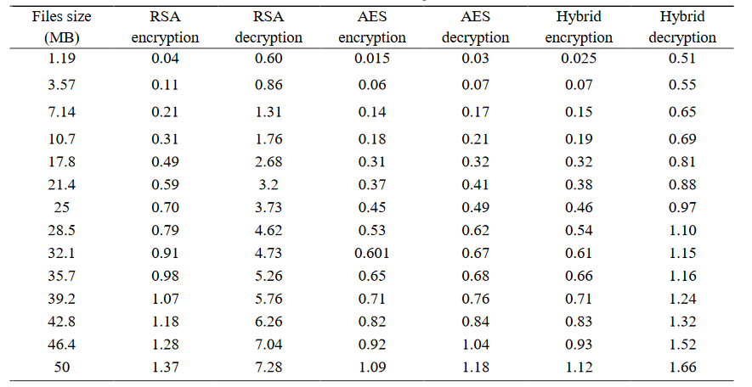
Table 2.1: Time taken for each encryption and decryption models in seconds

The hybrid encryption algorithm provides the highest level of data security than other algorithms, and its speed is much faster than RSA and slightly slower than AES algorithms. The hybrid encryption algorithm, which is 67.47% faster than the RSA algorithm and 32.39% slower than the AES algorithm, can be used in software applications, system design, and other fields where data security is required. The algorithm can effectively protect data while maintaining performance and fast execution times. These findings are supported by the experiments conducted for this paper.

[7] In this paper, a survey of RSA, DES and AES encryption algorithms are presented. This paper presents a detailed study of the popular encryption algorithms such as RSA, DES and AES. A thorough analysis of well-known encryption methods including RSA, DES, and AES is presented in this work. The network and internet are being used more and more frequently. As a result, additional needs exist to safeguard data transferred over various networks with various services. Several encryption techniques are employed to safeguard the network. An overview of previous studies on encryption techniques is presented in this publication. Therefore, real-time encryption can benefit from all of the strategies. Every technique is distinct in its own right, with potential applicability for a range of uses as well as benefits and drawbacks. The literature review indicates that the AES algorithm is the most effective in terms of avalanche, speed, time, and throughput.
[8] This research attempts to make a comparative evaluation of two encryption algorithms Advanced Encryption Standard (AES) and Rivest Shamir Algorithm (RSA) in order to ascertain the most reliable in terms of their encryption time, decryption time, Key length, and cipher length. The results obtained from the development revealed that AES is considered more efficient because it uses lesser time for encryption and decryption, reduces cipher and key length as compared with RSA which consumes longer encryption and decryption time, and increases cipher and key length. Excel package was also used to display the pictorial representation of the comparison between these algorithms.
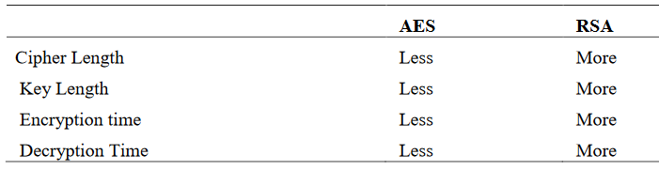
Table 2.2: Difference between AES and RSA on the basis of key and time

A symmetric block encryption algorithm (Advanced Encryption Standard) and an Asymmetric block encryption algorithm (Rivest Shamir Algorithm) were compared to test their performances in terms of encryption time, decryption time, cipher length, and key length. The result shows that AES is better between the two encryption techniques. The author is recommending AES as a good algorithm for security measures especially in the development of mobile applications.

[9] In order to provide a safe environment, the aim of this paper is to analyze the well-known symmetric algorithm of the Advanced Encryption Standard (AES) and the Rivest–Shamir–Adleman (RSA) asymmetric algorithm based on time complexity, space, resource and power consumption, and suggest a new hybrid encryption process that is a combination of symmetric and asymmetric cryptographic methods.
The methodology part of this paper delves into the intricacies of RSA and AES, two asymmetric and symmetric algorithms, and suggests a better technique for ensuring optimum cloud computing security. The AES algorithm outperforms the RSA algorithm in terms of memory requirements and has a lower time complexity. It is also easier to build because of its flexible and scalable behavior. With its high security level, the AES algorithm guards data and is capable of counterattacking against many types of attacks.But as technology advances quickly, hybrid models are replacing traditional security methods. As a result, a hybrid AES and RSA approach will improve cloud security as a whole.
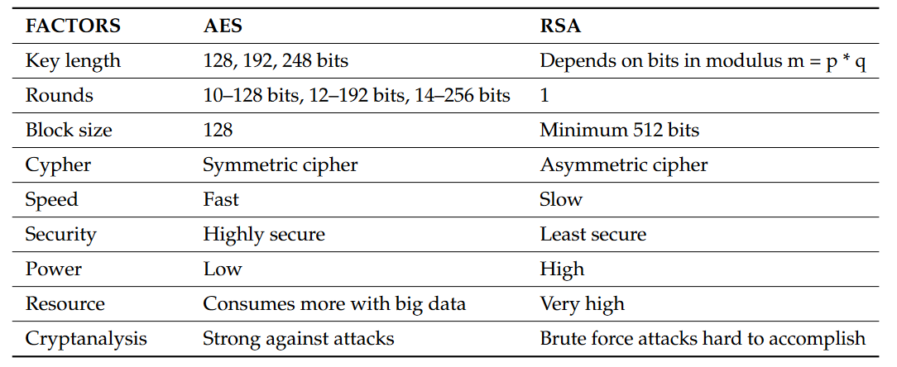
Table 2.3: Difference between AES and RSA based on different factors

[10] In an attempt to carry out a comparative assessment, we considered Rivest-Shamir- Adleman (RSA), Advanced Encryption Standard (AES) and Data Encryption Standard (DES) algorithms. Since there is skepticism on which of the algorithms is more reliable, dependable and functional when considering features that characterized their variation, this work therefore attempts to do a comparative assessment of each of the encryption algorithms to ascertain the best using the stated metrics. The implementation was carried out with C#. The results obtained from the experimentation revealed that AES uses the lowest time for encryption while RSA consumes the longest encryption time. Also, AES algorithm is considered the most efficient of all the three algorithms based on the metrics used for the evaluation
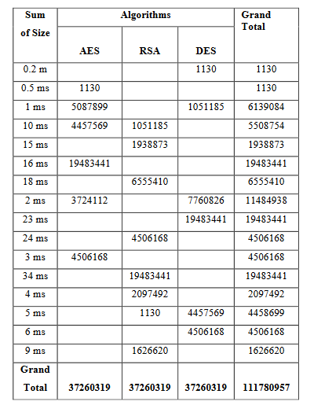
Table 2.4: Detailed time comparison of Audio Video encryption algorithms

Chapter - 3
Methodology
Chapter - 3 Methodology

The approach or planning for the project is to create a program that implements the hybrid implementation of AES and RSA algorithms and AES and Triple DES algorithms respectively i.e. encrypts the data using both the algorithms and also decrypts in a suitable manner. The implementation of the algorithms matters as it will decide the parameters that will make the process more or less efficient which includes time and space complexity, strength of cypher, speed of execution, size of the encrypted media, effectiveness, and their applicability in different scenarios.

1. AES - Advanced Encryption Standard

AES encrypts a plaintext to a cipher text, which can be decoded back to the original plaintext with a shared private key. As can be seen, the cipher text should differ from the original plaintext and provide no hints about it. Where the plain text is provided with a key cipher text, which is the output of the encryption process, is created by the encryptor from plain text. When the decryptor receives the encrypted text and key, it reverses the process and returns the original plain text.

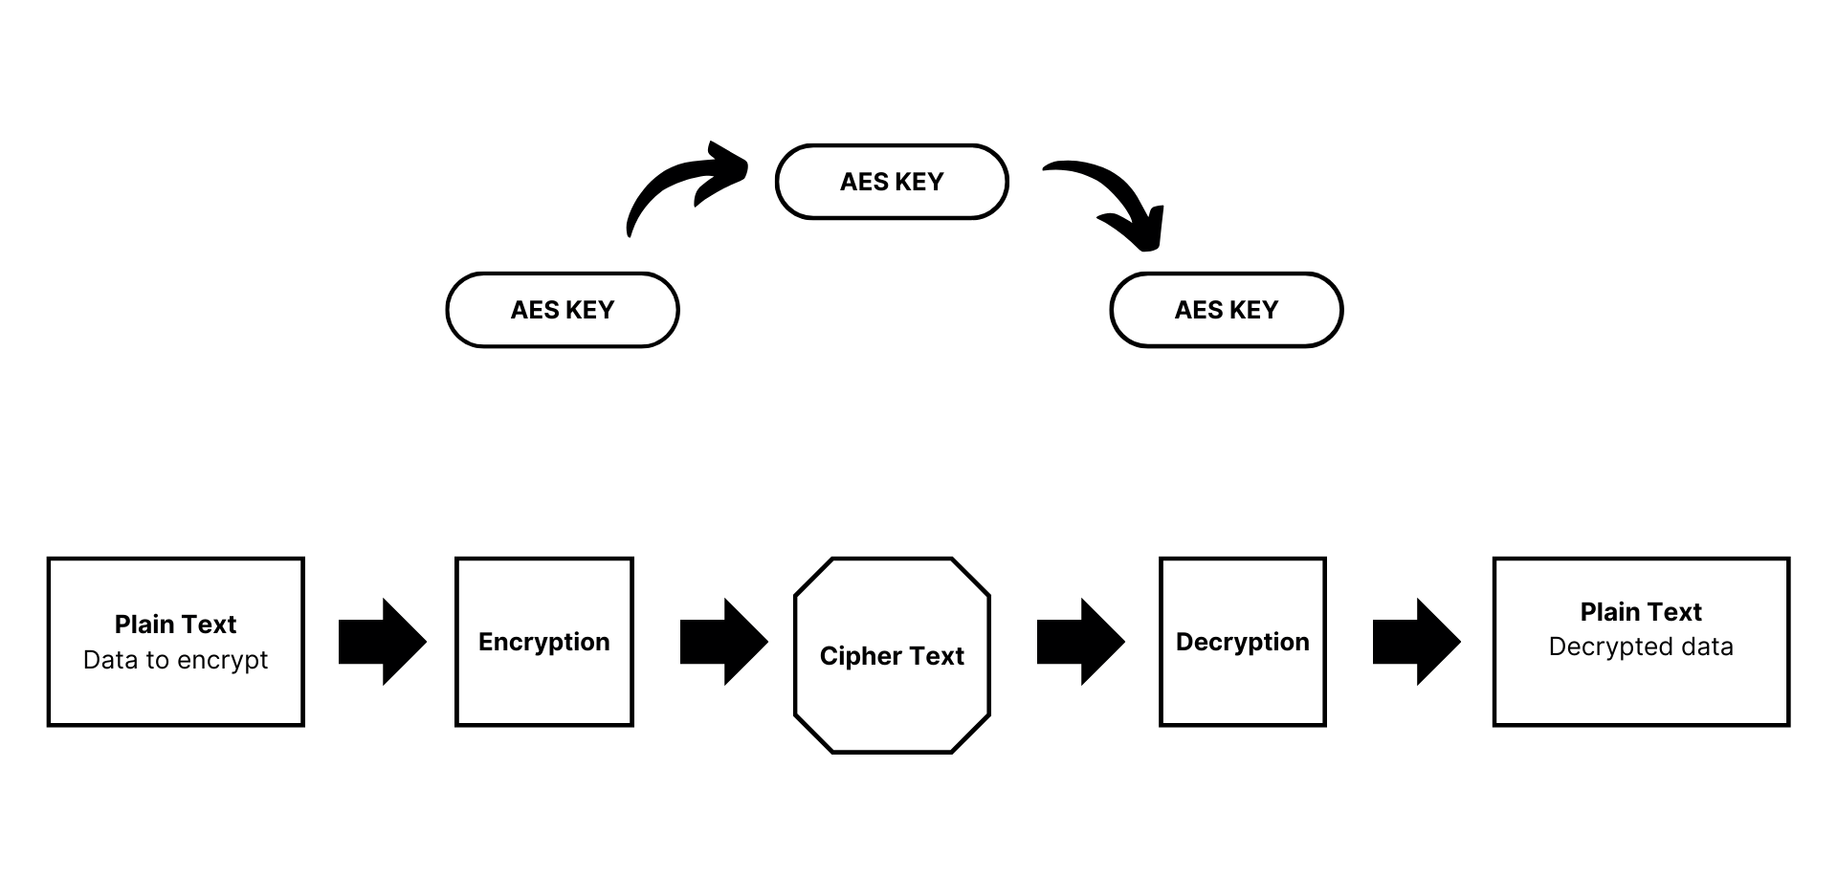
Fig. 3.1: AES Encryption & Decryption

2. RSA - Rivest, Shamir, Adleman

RSA encryption and decryption can be applied to image and video files in a similar way as with text data, but with some considerations due to the size and format of these files. Here's a general approach for encrypting and decrypting image and video files using RSA:

Encryption:

- Convert the Image/Video to a Byte Array: Read the image or video file and convert it into a byte array. This array will represent the raw data of the file.
- Segmentation (Optional): If the file size exceeds the RSA key length (e.g., 2048 bits), segment the byte array into smaller blocks that fit within the key length.
- Encryption: For each segment, perform RSA encryption using the public key. This results in encrypted segments.
- Output: Save the encrypted segments as a file or transmit them securely over a network.

Decryption:

- Decryption: For each encrypted segment, perform RSA decryption using the private key to obtain the original byte array segments.
- Reassembly (Optional): If the file was segmented during encryption, reassemble the byte array segments into a single byte array.
- Conversion to Image/Video: Convert the byte array back to its original image or video format.
- Output: Save the decrypted image or video file

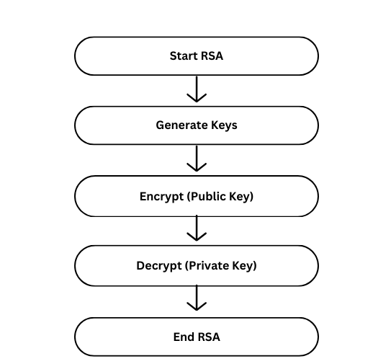
Fig. 3.2: RSA Encryption & Decryption

3. Triple DES- Triple Encryption Standard

Triple DES (3DES), also known as TDEA or DESede, is a symmetric encryption algorithm that enhances the original Data Encryption Standard (DES). It applies the DES algorithm three times sequentially, using three different keys for increased security. Despite its improved security over DES, 3DES is now considered somewhat outdated due to its key length limitations and has been largely replaced by more modern encryption standards, such as Advanced Encryption Standard (AES).

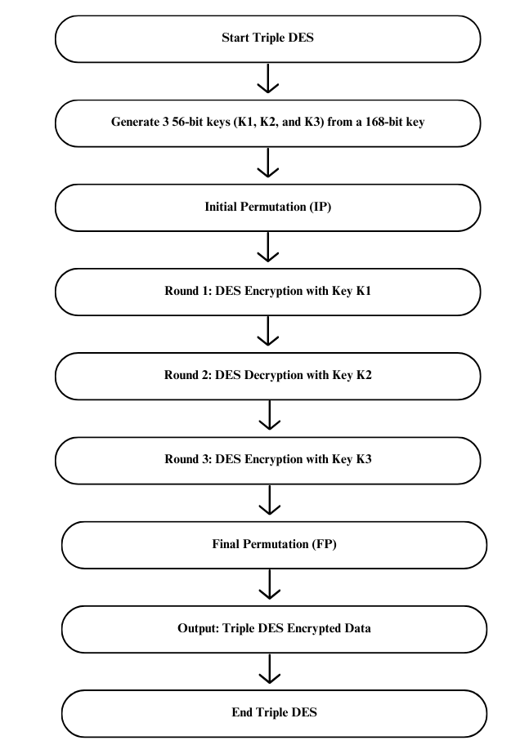
Fig. 3.3: Triple DES- Triple Encryption Standard

3.1 Implementing AES and RSA in a hybrid manner

AES and RSA algorithms together for encrypting and decrypting image and video files involves using AES for symmetric encryption of the actual file data and RSA for asymmetric encryption of the symmetric key used by AES

Encryption:

Generate Keys:
Generate an AES symmetric key (e.g., 128, 192, or 256 bits) for encrypting the image or video file.
Generate an RSA key pair (public and private keys) for encrypting the AES key.

Encrypting the Image/Video File:
Read the image or video file into memory.
Use AES with the generated symmetric key to encrypt the file data.
AES encryption ensures that the file data is securely scrambled.

Encrypting the AES Key with RSA:
Encrypt the AES symmetric key using RSA and the recipient's public key.
This step allows securely sharing the AES key with the recipient without exposing it to potential eavesdroppers.

Output:
Save the RSA-encrypted AES key and the AES-encrypted image or video file as separate files.
These files are what will be transmitted or stored securely.

Decryption:

Retrieve Files:
Obtain the RSA-encrypted AES key and the AES-encrypted image or video file.

Decrypting the AES Key with RSA:
Decrypt the RSA-encrypted AES key using RSA and the recipient's private key.
This retrieves the original AES symmetric key used for encryption.

Decrypting the Image/Video File with AES:
Use the decrypted AES symmetric key to decrypt the AES-encrypted image or video file.
AES decryption reverses the encryption process, restoring the original file data.

Output:
Save the decrypted image or video file.
The decrypted file is now accessible and readable by the recipient.

AES and RSA features:

Security: RSA is used for key exchange and encrypting the AES key. AES is used for encrypting the actual data. This approach provides strong security, as AES provides the symmetric encryption strength, while RSA ensures the secure exchange of the AES key.

Speed: RSA is slower compared to AES, especially for key exchange. However, since AES is used for encrypting the bulk data, which is typically larger in size (images and videos), the overall speed is more dependent on AES.

Use Case: This approach is suitable for scenarios where secure key exchange and strong encryption of large data sets (images and videos) are required. It provides a good balance between security and performance.

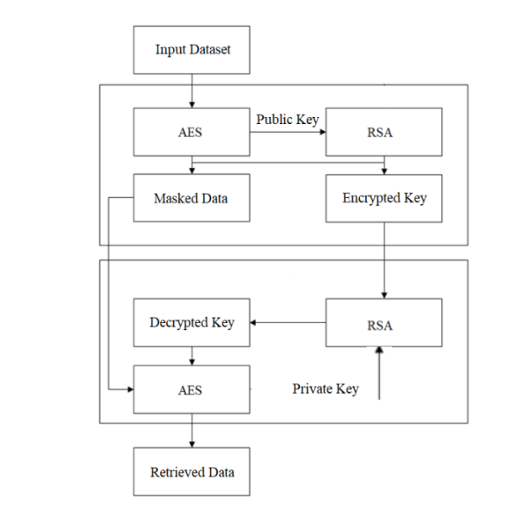
Fig. 3.4: Hybrid implementation of AES & RSA

3.2 Implementing AES and Triple DES in a hybrid manner

The process for encrypting and decrypting image and video files using a combination of AES for symmetric encryption and Triple DES (3DES) for asymmetric encryption of the symmetric key can be outlined as follows:

Encryption:

Generate Keys:
Generate an AES symmetric key (128, 192, or 256 bits) for encrypting the image or video file.
Generate a 3DES key (typically 168 bits) for encrypting the AES symmetric key.

Encrypting the Image/Video File with AES:
Read the image or video file into memory.
Use AES with the generated symmetric key to encrypt the file data.
AES encryption ensures that the file data is securely scrambled.

Encrypting the AES Key with 3DES:
Encrypt the AES symmetric key using 3DES and the recipient's public key.
This step allows securely sharing the AES key with the recipient without exposing it to potential eavesdroppers.

Output:
Save the 3DES-encrypted AES key and the AES-encrypted image or video file as separate files.
These files are what will be transmitted or stored securely.

Decryption:

Retrieve Files:
Obtain the 3DES-encrypted AES key and the AES-encrypted image or video file.

Decrypting the AES Key with 3DES:
Decrypt the 3DES-encrypted AES key using 3DES and the recipient's private key.
This retrieves the original AES symmetric key used for encryption.

Decrypting the Image/Video File with AES:
Use the decrypted AES symmetric key to decrypt the AES-encrypted image or video file.
AES decryption reverses the encryption process, restoring the original file data.

Output:
Save the decrypted image or video file.
The decrypted file is now accessible and readable by the recipient.

AES is used for symmetric encryption, ensuring efficiency and speed in encrypting and decrypting large amounts of data.
Triple DES (3DES) is used for asymmetric encryption of the AES symmetric key, providing an additional layer of security.
The choice of key lengths for both AES and 3DES depends on security requirements and considerations.

Hybrid encryption combines symmetric and asymmetric encryption to take advantage of the strengths of both. Here's a comparative analysis of hybrid encryption using AES and RSA versus AES and Triple DES for images and videos:

AES and Triple DES features:

Security: Similar to the AES and RSA approach, Triple DES can be used for key exchange and encrypting the AES key, while AES is used for encrypting the data. However, Triple DES is considered less secure than RSA for key exchange.

Speed: Triple DES is slower than AES and RSA, especially for large data sets. This can impact the overall performance of the encryption process, especially for real-time encryption of images and videos.

Use Case: While this approach can be used in scenarios where AES and Triple DES are preferred or required, it is not as commonly used as AES and RSA due to Triple DES's slower speed and lower security compared to RSA.

The hybrid encryption of AES and RSA is generally preferred for encrypting images and videos due to its strong security and efficient performance. The hybrid encryption of AES and Triple DES can be used in specific scenarios where AES and Triple DES are required or preferred, but it is less common due to Triple DES's slower speed and lower security compared to RSA.

One use case for hybrid encryption of AES and RSA or AES and Triple DES for images and videos is in secure file transfer systems, such as those used in cloud storage services or secure messaging applications.

In such a system, when a user wants to upload an image or video file, the following process could be employed:

- Key Exchange:
  - The user's client application generates a random AES key to encrypt the image or video file.
  - The client then uses RSA (or Triple DES) to encrypt the AES key.
  - This encrypted AES key is sent to the server along with the encrypted image or video file.

- Encryption:
  - The image or video file is encrypted using AES with the random AES key.
  - The encrypted file is then sent to the server along with the encrypted AES key.

- Decryption:
  - When the file needs to be accessed, the server sends the encrypted file and the encrypted AES key back to the client.
  - The client uses its private RSA key (or Triple DES key) to decrypt the AES key.
  - The client then uses the decrypted AES key to decrypt the image or video file.
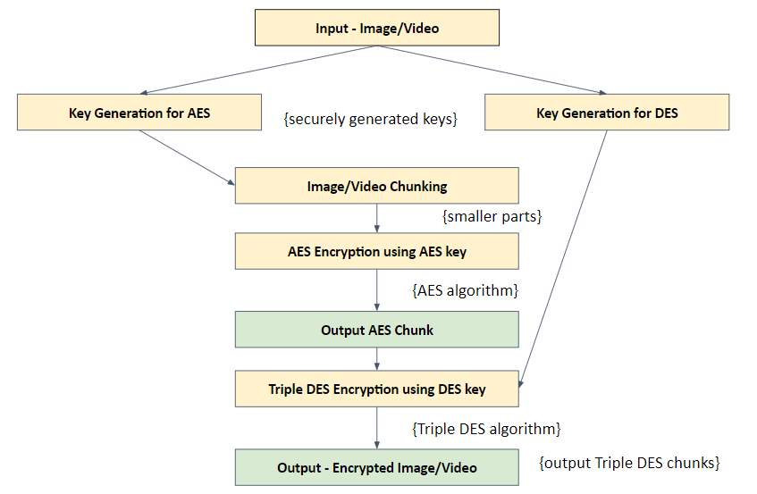

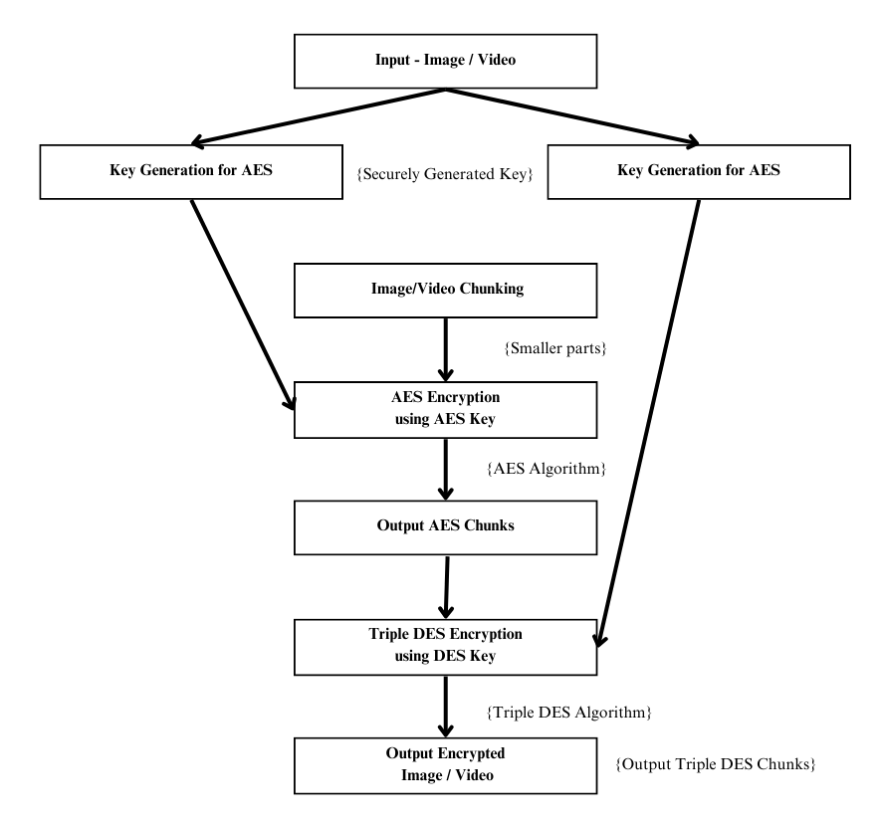

Fig. 3.5: Hybrid implementation of AES & Triple DES

This approach ensures that the image or video file is encrypted with a strong symmetric encryption algorithm (AES), while the key exchange is done using a secure asymmetric encryption algorithm (RSA or Triple DES). This provides a high level of security for the file transfer process, protecting the data from unauthorized access during transmission and storage.

Therefore, implementing the AES and RSA algorithms and AES and Triple DES algorithms respectively and then making a comparative analysis of their performance while they encrypt and decrypt multimedia files such as images and videos.

Chapter - 4
Results and Discussions

Chapter - 4 Results and Discussions

4.1 Implementation of the AES and RSA algorithm for encryption of Images

The following is an implementation of the AES and RSA algorithm for encryption of images. The implementation has been done using the JAVA programming language.

Code:

import javax.crypto.*;
import java.io.*;
import java.nio.file.Files;
import java.nio.file.Paths;
import java.security.*;
import javax.crypto.spec.SecretKeySpec;

public class AESRSAImage {

public static void main(String[] args) {
try {
// Generate RSA key pair (public and private keys) for key exchange
KeyPair keyPair = generateKeyPair();

// Generate AES key for encrypting image data
SecretKey aesKey = generateAESKey();

// Specify the paths for the input and output images
String inputImagePath = <input-image-path-goes-here>;
String encryptedImagePath = <output-path-goes-here>;
String decryptedImagePath = <output-path-goes-here>;

// Encrypt the image using AES with a randomly generated key
encryptImage(inputImagePath, encryptedImagePath, aesKey);

// Encrypt the AES key using the RSA public key
byte[] encryptedAESKey = encryptAESKey(aesKey, keyPair.getPublic());

// Decrypt the AES key using the RSA private key
SecretKey decryptedAESKey = decryptAESKey(encryptedAESKey, keyPair.getPrivate());

// Decrypt the image using the decrypted AES key
decryptImage(encryptedImagePath, decryptedImagePath, decryptedAESKey);

System.out.println("Hybrid Encryption and Decryption completed successfully!");
} catch (Exception e) {
e.printStackTrace();
}
}

private static KeyPair generateKeyPair() throws NoSuchAlgorithmException {
KeyPairGenerator keyPairGenerator = KeyPairGenerator.getInstance("RSA");
keyPairGenerator.initialize(2048);
return keyPairGenerator.generateKeyPair();
}

private static SecretKey generateAESKey() throws NoSuchAlgorithmException {
KeyGenerator keyGenerator = KeyGenerator.getInstance("AES");
keyGenerator.init(128); // You can adjust the key size as needed (128, 192, or 256 bits)
return keyGenerator.generateKey();
}u

private static void encryptImage(String inputImagePath, String outputImagePath, SecretKey aesKey) throws Exception {
Cipher cipher = Cipher.getInstance("AES");
cipher.init(Cipher.ENCRYPT_MODE, aesKey);

byte[] inputBytes = Files.readAllBytes(Paths.get(inputImagePath));
byte[] encryptedBytes = cipher.doFinal(inputBytes);

try (FileOutputStream outputStream = new FileOutputStream(outputImagePath)) {
outputStream.write(encryptedBytes);
}
}

private static byte[] encryptAESKey(SecretKey aesKey, PublicKey publicKey) throws Exception {
Cipher cipher = Cipher.getInstance("RSA/ECB/PKCS1Padding");
cipher.init(Cipher.ENCRYPT_MODE, publicKey);
return cipher.doFinal(aesKey.getEncoded());
}

private static SecretKey decryptAESKey(byte[] encryptedAESKey, PrivateKey privateKey) throws Exception {
Cipher cipher = Cipher.getInstance("RSA/ECB/PKCS1Padding");
cipher.init(Cipher.DECRYPT_MODE, privateKey);
byte[] decryptedBytes = cipher.doFinal(encryptedAESKey);
return new SecretKeySpec(decryptedBytes, "AES");
}

private static void decryptImage(String inputImagePath, String outputImagePath, SecretKey aesKey) throws Exception {
Cipher cipher = Cipher.getInstance("AES");
cipher.init(Cipher.DECRYPT_MODE, aesKey);
byte[] encryptedBytes = Files.readAllBytes(Paths.get(inputImagePath));
byte[] decryptedBytes = cipher.doFinal(encryptedBytes);

try (FileOutputStream outputStream = new FileOutputStream(outputImagePath)) {
outputStream.write(decryptedBytes);
}
}
}

Output:

Hybrid Encryption and Decryption completed successfully!

Results:

Lines of Code (LOC) | 58 lines
Time Complexity
Key Pair Generation (RSA) | O(n^2) or O(n^3)
AES Key Generation | O(1)
Image Encryption (AES) | O(m)
AES Key Encryption (RSA) | O(k^3)
AES Key Decryption (RSA) | O(k^3)
Image Decryption (AES) | O(m)
Space Complexity
Key Pair Generation (RSA) | O(1)
AES Key Generation | O(1)
Image Encryption (AES) | O(m)
AES Key Encryption (RSA) | O(k)
AES Key Decryption (RSA) | O(k)
Image Decryption (AES) | O(m)

Table 4.1.1: Complexity analysis for AES and RSA for Images

The overall notation for the time and space complexity:
Time Complexity | O(m + k^3 + n^3)
Space Complexity | O(m + k + n)

Table 4.1.2: Overall complexity notations for AES and RSA for Images

Here, n represents the key size in RSA (2048 bits), m represents the size of the image, and k represents the key size in AES (128 bits).
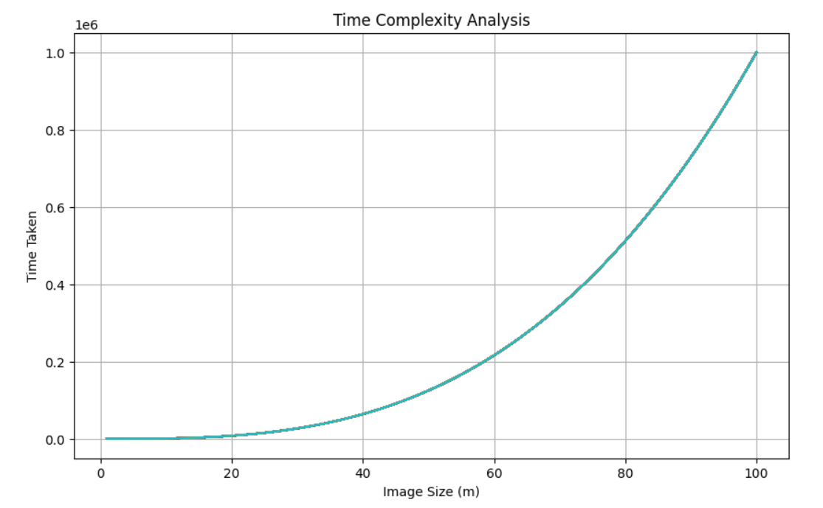
Fig. 4.1.1: Time Complexity Graph of AES and RSA for Images

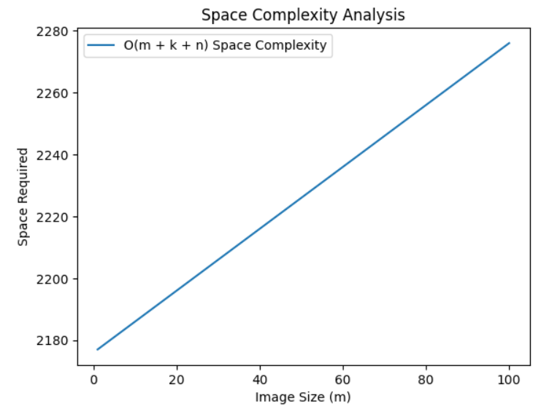
Fig. 4.1.2: Space Complexity Analysis graph of AES and RSA for Images

Strength Analysis:

- RSA Encryption: The code employs RSA with a key size of 2048 bits, which is considered secure for the foreseeable future against classical and quantum attacks.

- AES Encryption: AES with a 128-bit key is used for encrypting image data. While AES with a 128-bit key is still widely used and considered secure, using a larger key size like 256 bits might provide an extra layer of security against future advancements in cryptanalysis.

- Hybrid Encryption: The code utilizes a hybrid encryption scheme combining RSA and AES. This approach leverages the strengths of both algorithms: RSA for key exchange and AES for efficient bulk encryption. It ensures confidentiality and integrity of the data while minimizing computational overhead.

Overall, the code implements a strong encryption scheme suitable for protecting image data in transit or at rest. However, it's essential to stay updated with advancements in cryptography and periodically reassess the choice of key sizes and algorithms to maintain robust security posture.

4.2 Implementation of the AES and RSA algorithm for encryption of Videos

The following is an implementation of the AES and RSA algorithm for encryption of Videos. The implementation has been done using JAVA programming language.

Code:

import javax.crypto.*;
import javax.crypto.spec.SecretKeySpec;
import java.io.*;
import java.nio.file.Files;
import java.nio.file.Paths;
import java.security.*;

public class AESRSAVideo {

public static void main(String[] args) {
try {
// Generate RSA key pair (public and private keys) for key exchange
KeyPair keyPair = generateKeyPair();

// Generate AES key for encrypting video data
SecretKey aesKey = generateAESKey();

// Specify the paths for the input and output videos
String inputVideoPath = <input-video-path-goes-here>;
String encryptedVideoPath = <output-path-goes-here>;
String decryptedVideoPath = <output-path-goes-here>;

// Encrypt the video using AES with a randomly generated key
encryptVideo(inputVideoPath, encryptedVideoPath, aesKey);

// Encrypt the AES key using the RSA public key
byte[] encryptedAESKey = encryptAESKey(aesKey, keyPair.getPublic());

// Decrypt the AES key using the RSA private key
SecretKey decryptedAESKey = decryptAESKey(encryptedAESKey, keyPair.getPrivate());

// Decrypt the video using the decrypted AES key
decryptVideo(encryptedVideoPath, decryptedVideoPath, decryptedAESKey);

System.out.println("Hybrid Encryption and Decryption completed successfully!");
} catch (Exception e) {
e.printStackTrace();
}
}

private static KeyPair generateKeyPair() throws NoSuchAlgorithmException {
KeyPairGenerator keyPairGenerator = KeyPairGenerator.getInstance("RSA");
keyPairGenerator.initialize(2048);
return keyPairGenerator.generateKeyPair();
}

private static SecretKey generateAESKey() throws NoSuchAlgorithmException {
KeyGenerator keyGenerator = KeyGenerator.getInstance("AES");
keyGenerator.init(256); // Adjusted to 256-bit AES key size
return keyGenerator.generateKey();
}

private static void encryptVideo(String inputVideoPath, String outputVideoPath, SecretKey aesKey) throws Exception {
Cipher cipher = Cipher.getInstance("AES");
cipher.init(Cipher.ENCRYPT_MODE, aesKey);

try (InputStream inputStream = new FileInputStream(inputVideoPath);
OutputStream outputStream = new FileOutputStream(outputVideoPath)) {

byte[] buffer = new byte[1024];
int bytesRead;
while ((bytesRead = inputStream.read(buffer)) != -1) {
byte[] encryptedBytes = cipher.update(buffer, 0, bytesRead);
if (encryptedBytes != null) {
outputStream.write(encryptedBytes);
}
}

byte[] finalBytes = cipher.doFinal();
if (finalBytes != null) {
outputStream.write(finalBytes);
}
}
}

private static byte[] encryptAESKey(SecretKey aesKey, PublicKey publicKey) throws Exception {
Cipher cipher = Cipher.getInstance("RSA/ECB/PKCS1Padding");
cipher.init(Cipher.ENCRYPT_MODE, publicKey);
return cipher.doFinal(aesKey.getEncoded());
}

private static SecretKey decryptAESKey(byte[] encryptedAESKey, PrivateKey privateKey) throws Exception {
Cipher cipher = Cipher.getInstance("RSA/ECB/PKCS1Padding");
cipher.init(Cipher.DECRYPT_MODE, privateKey);
byte[] decryptedBytes = cipher.doFinal(encryptedAESKey);
return new SecretKeySpec(decryptedBytes, "AES");
}

private static void decryptVideo(String inputVideoPath, String outputVideoPath, SecretKey aesKey) throws Exception {
Cipher cipher = Cipher.getInstance("AES");
cipher.init(Cipher.DECRYPT_MODE, aesKey);

try (InputStream inputStream = new FileInputStream(inputVideoPath);
OutputStream outputStream = new FileOutputStream(outputVideoPath)) {

byte[] buffer = new byte[1024];
int bytesRead;
while ((bytesRead = inputStream.read(buffer)) != -1) {
byte[] decryptedBytes = cipher.update(buffer, 0, bytesRead);
if (decryptedBytes != null) {
outputStream.write(decryptedBytes);
}
}

byte[] finalBytes = cipher.doFinal();
if (finalBytes != null) {
outputStream.write(finalBytes);
}
}
}
}

Output:

Hybrid Encryption and Decryption completed successfully!

Results:

Lines of Code (LOC) | 74 lines
Time Complexity
Key Pair Generation (RSA) | O(n^3)
AES Key Generation | O(1)
Video Encryption (AES) | O(m)
AES Key Encryption (RSA) | O(k^3)
AES Key Decryption (RSA) | O(k^3)
Video Decryption (AES) | O(m)
Space Complexity
Key Pair Generation (RSA) | O(1)
AES Key Generation | O(1)
Video Encryption (AES) | O(m)
AES Key Encryption (RSA) | O(k)
AES Key Decryption (RSA) | O(k)
Video Decryption (AES) | O(m)
Table 4.2.1: Complexity analysis for AES and RSA for Videos

The overall notation for the time and space complexity:
Time Complexity | O(n^3 + m + k^3)
Space Complexity | O(m + k + n)

Table 4.2.2: Overall complexity notations for AES and RSA for Videos

Here, n represents the RSA key size (2048 bits), m represents the size of the video file, and k represents the AES key size (256 bits).

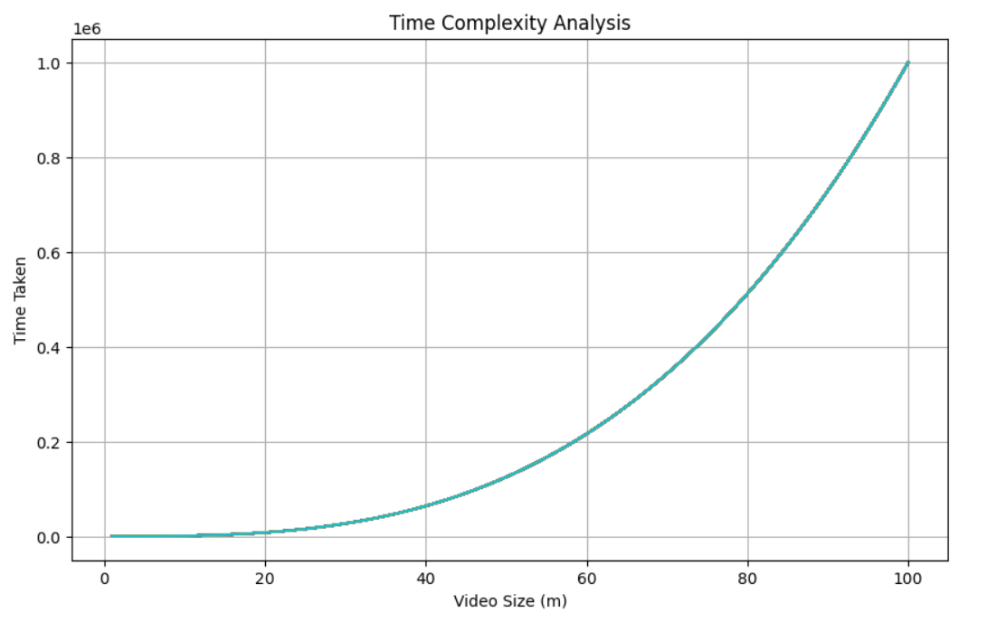
Fig. 4.2.1: Time Complexity Graph of AES and RSA for Videos

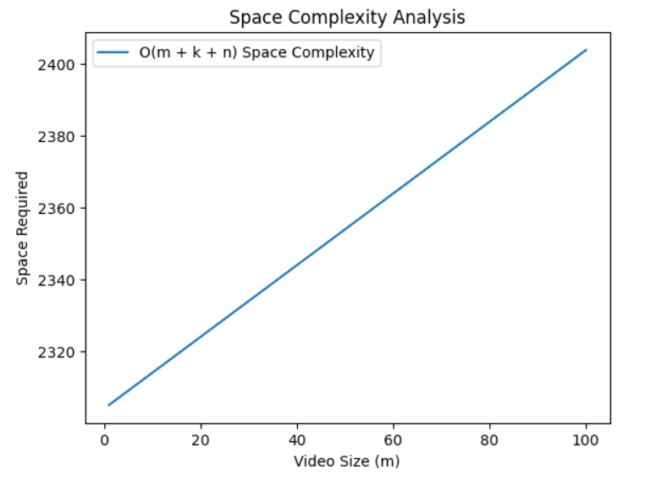
Fig. 4.2.2: Space Complexity Graph of AES and RSA for Videos

Strength Analysis:

- RSA Key Size: The RSA key size is set to 2048 bits, which is considered strong enough for most applications as of the last update in 2022.

- AES Key Size: The AES key size is set to 256 bits, providing strong encryption.

- Padding Scheme: PKCS1Padding is used for RSA encryption and decryption, which is a standard padding scheme.

- Mode of Operation: ECB mode is used for both RSA and AES encryption, which has certain vulnerabilities. It's recommended to use more secure modes like CBC or GCM.

Overall, the code seems to implement hybrid encryption using strong cryptographic primitives. However, using more secure modes of operation for encryption could further enhance its security.

4.3 Implementation of the AES and Triple DES algorithm for encryption of Images

The following is an implementation of the AES and RSA algorithm for encryption of Videos. The implementation has been done using JAVA programming language.

Code:

import javax.crypto.*;
import javax.crypto.spec.SecretKeySpec;
import java.io.*;
import java.nio.file.Files;
import java.nio.file.Paths;
import java.security.*;

public class AESTDESImage {

public static void main(String[] args) {
try {
// Generate AES key for encrypting image data
SecretKey aesKey = generateAESKey();

// Generate Triple DES key for encrypting image data
SecretKey tripleDesKey = generateTripleDesKey();

// Specify the paths for the input and output images
String inputImagePath = <input-image-path-goes-here>;
String encryptedAesImagePath = <output-path-goes-here>;
String encryptedTripleDesImagePath = <output-path-goes-here>;
String decryptedAesImagePath = <output-path-goes-here>;
String decryptedTripleDesImagePath = <output-path-goes-here>;

// Encrypt the image using AES
encryptImage(inputImagePath, encryptedAesImagePath, aesKey);

// Encrypt the image using Triple DES
encryptImage(inputImagePath, encryptedTripleDesImagePath, tripleDesKey);

// Decrypt the AES encrypted image
decryptImage(encryptedAesImagePath, decryptedAesImagePath, aesKey);

// Decrypt the Triple DES encrypted image
decryptImage(encryptedTripleDesImagePath, decryptedTripleDesImagePath, tripleDesKey);

System.out.println("Hybrid Image Encryption and Decryption completed successfully!");
} catch (Exception e) {
e.printStackTrace();
}
}

private static SecretKey generateAESKey() throws NoSuchAlgorithmException {
KeyGenerator keyGenerator = KeyGenerator.getInstance("AES");
keyGenerator.init(256); // 256-bit key size
return keyGenerator.generateKey();
}

private static SecretKey generateTripleDesKey() throws NoSuchAlgorithmException {
KeyGenerator keyGenerator = KeyGenerator.getInstance("DESede");
keyGenerator.init(168); // 168-bit key size
return keyGenerator.generateKey();
}

private static void encryptImage(String inputImagePath, String outputImagePath, SecretKey key) throws Exception {
Cipher cipher = Cipher.getInstance(key.getAlgorithm());
cipher.init(Cipher.ENCRYPT_MODE, key);

byte[] inputBytes = Files.readAllBytes(Paths.get(inputImagePath));
byte[] encryptedBytes = cipher.doFinal(inputBytes);

try (FileOutputStream outputStream = new FileOutputStream(outputImagePath)) {
outputStream.write(encryptedBytes);
}
}

private static void decryptImage(String inputImagePath, String outputImagePath, SecretKey key) throws Exception {
Cipher cipher = Cipher.getInstance(key.getAlgorithm());
cipher.init(Cipher.DECRYPT_MODE, key);

byte[] encryptedBytes = Files.readAllBytes(Paths.get(inputImagePath));
byte[] decryptedBytes = cipher.doFinal(encryptedBytes);

try (FileOutputStream outputStream = new FileOutputStream(outputImagePath)) {
outputStream.write(decryptedBytes);
}
}
}

Output:

Hybrid Encryption and Decryption completed successfully!

Results:

Lines of Code (LOC) | 74 lines
Time Complexity
Key Pair Generation (TDES) | O(1)
AES Key Generation | O(1)
Image Encryption (AES) | O(m)
Image Decryption (AES) | O(m)
Space Complexity
Key Pair Generation (TDES) | O(1)
AES Key Generation | O(1)
Image Encryption (AES) | O(m)
Image Decryption (AES) | O(m)
Table 4.3.1: Complexity analysis for AES and TDES for Images

The overall notation for the time and space complexity:
Time Complexity | O(m)
Space Complexity | O(m)

Table. 4.3.2: Overall complexity notations for AES and TDES for Images
Here, m represents the size of the image.
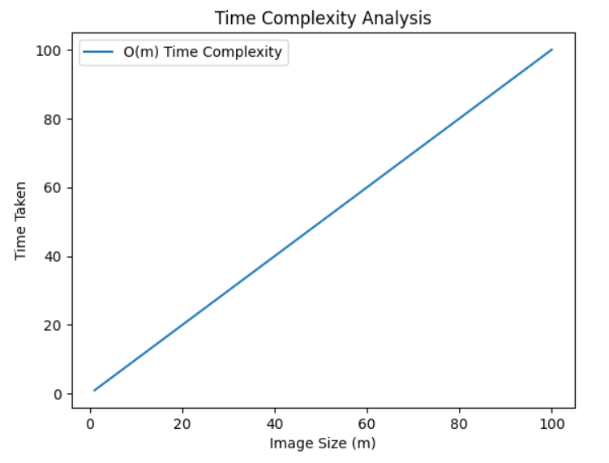
Fig. 4.3.1: Time Complexity Graph of AES and TDES for Images

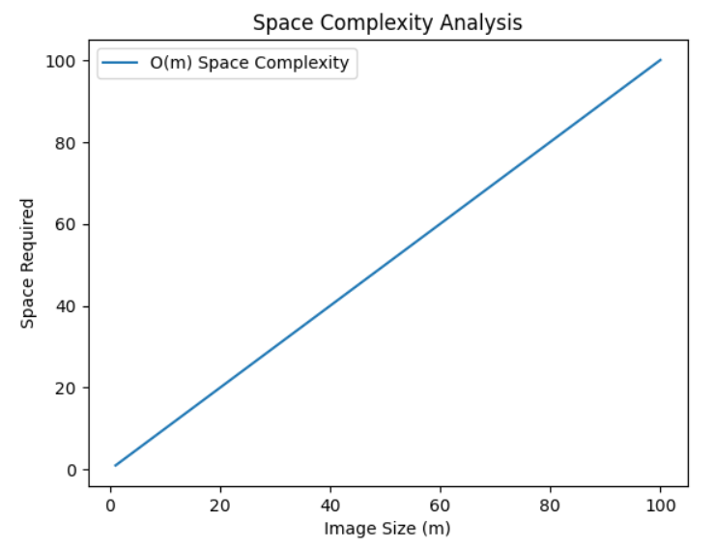
Fig. 4.3.2: Space Complexity Graph of AES and TDES for Images

Strength Analysis:

- AES: AES with a 256-bit key is considered very secure and is widely used in practice.

- Triple DES: While Triple DES (3DES) was once considered secure, its 168-bit key length is now considered insufficient for modern security requirements. It's generally recommended to use AES instead of Triple DES for new applications.

Overall, AES provides stronger security compared to Triple DES due to its longer key length. Therefore, in terms of strength, using AES is preferred over Triple DES.

4.4 Implementation of the AES and Triple DES algorithm for encryption of Videos

The following is an implementation of the AES and RSA algorithm for encryption of Videos. The implementation has been done using JAVA programming language.

Code:

import javax.crypto.*;
import javax.crypto.spec.SecretKeySpec;
import java.io.*;
import java.nio.file.Files;
import java.nio.file.Paths;
import java.security.*;

public class AESTDESVideo {

public static void main(String[] args) {
try {
// Generate AES key for encrypting video data
SecretKey aesKey = generateAESKey();

// Generate Triple DES key for encrypting video data
SecretKey tripleDesKey = generateTripleDesKey();

// Specify the paths for the input and output videos
String inputVideoPath = <input-video-path-goes-here>;
String encryptedAesVideoPath = <output-path-goes-here>;
String encryptedTripleDesVideoPath = <output-path-goes-here>;
String decryptedAesVideoPath = <output-path-goes-here>;
String decryptedTripleDesVideoPath = <output-path-goes-here>;

// Encrypt the video using AES
encryptVideo(inputVideoPath, encryptedAesVideoPath, aesKey);

// Encrypt the video using Triple DES
encryptVideo(inputVideoPath, encryptedTripleDesVideoPath, tripleDesKey);

// Decrypt the AES encrypted video
decryptVideo(encryptedAesVideoPath, decryptedAesVideoPath, aesKey);

// Decrypt the Triple DES encrypted video
decryptVideo(encryptedTripleDesVideoPath, decryptedTripleDesVideoPath, tripleDesKey);

System.out.println("Hybrid Video Encryption and Decryption completed successfully!");
} catch (Exception e) {
e.printStackTrace();
}
}

private static SecretKey generateAESKey() throws NoSuchAlgorithmException {
KeyGenerator keyGenerator = KeyGenerator.getInstance("AES");
keyGenerator.init(256); // 256-bit key size
return keyGenerator.generateKey();
}

private static SecretKey generateTripleDesKey() throws NoSuchAlgorithmException {
KeyGenerator keyGenerator = KeyGenerator.getInstance("DESede");
keyGenerator.init(168); // 168-bit key size
return keyGenerator.generateKey();
}

private static void encryptVideo(String inputVideoPath, String outputVideoPath, SecretKey key) throws Exception {
Cipher cipher = Cipher.getInstance(key.getAlgorithm());
cipher.init(Cipher.ENCRYPT_MODE, key);

try (InputStream inputStream = new FileInputStream(inputVideoPath);
OutputStream outputStream = new FileOutputStream(outputVideoPath)) {

byte[] buffer = new byte[1024];
int bytesRead;
while ((bytesRead = inputStream.read(buffer)) != -1) {
byte[] encryptedBytes = cipher.update(buffer, 0, bytesRead);
if (encryptedBytes != null) {
outputStream.write(encryptedBytes);
}
}

byte[] finalBytes = cipher.doFinal();
if (finalBytes != null) {
outputStream.write(finalBytes);
}
}
}

private static void decryptVideo(String inputVideoPath, String outputVideoPath, SecretKey key) throws Exception {
Cipher cipher = Cipher.getInstance(key.getAlgorithm());
cipher.init(Cipher.DECRYPT_MODE, key);

try (InputStream inputStream = new FileInputStream(inputVideoPath);
OutputStream outputStream = new FileOutputStream(outputVideoPath)) {

byte[] buffer = new byte[1024];
int bytesRead;
while ((bytesRead = inputStream.read(buffer)) != -1) {
byte[] decryptedBytes = cipher.update(buffer, 0, bytesRead);
if (decryptedBytes != null) {
outputStream.write(decryptedBytes);
}
}

byte[] finalBytes = cipher.doFinal();
if (finalBytes != null) {
outputStream.write(finalBytes);
}
}
}
}

Output:

Hybrid Encryption and Decryption completed successfully!

Results:

Lines of Code (LOC) | 58 lines
Time Complexity
Key Pair Generation (TDES) | O(1)
AES Key Generation | O(1)
Video Encryption (AES) | O(m)
Video Decryption (AES) | O(m)
Space Complexity
Key Pair Generation (TDES) | O(1)
AES Key Generation | O(1)
Video Encryption (AES) | O(m)
Video Decryption (AES) | O(m)
Table 4.4.1: Complexity analysis for AES and TDES for Videos

The overall notation for the time and space complexity:
Time Complexity | O(m)
Space Complexity | O(m)

Table 4.4.2: Overall complexity notations for AES and TDES for Videos

Here, m represents the size of the image.

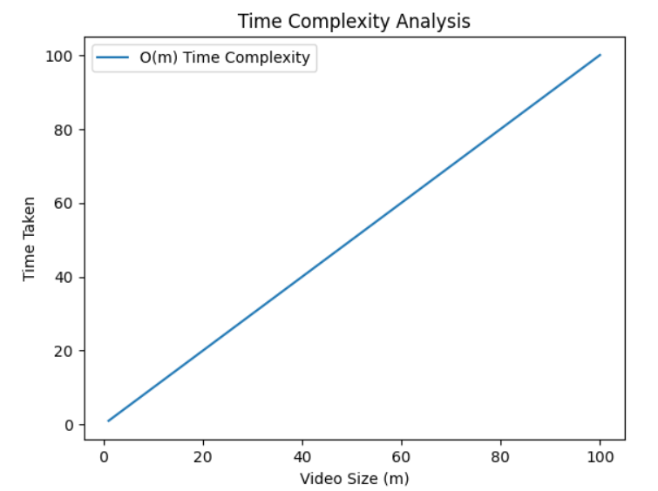
Fig. 4.4.1: Time Complexity Graph of AES and TDES for Videos

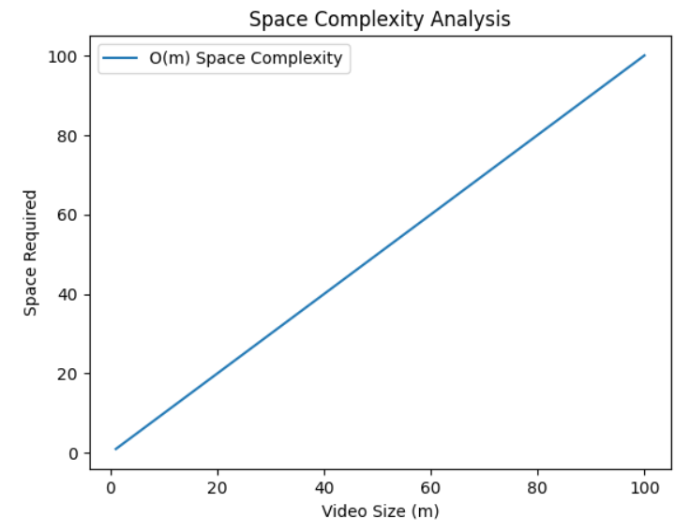
Fig. 4.4.2: Space Complexity Graph of AES and TDES for Videos

Strength Analysis:

- AES with a 256-bit key size is considered very secure and is widely recommended.

- Triple DES with a 168-bit key size was once considered secure, but it is now considered insufficient for modern security requirements. It's generally recommended to use at least 192 bits or preferably 256 bits for Triple DES to achieve comparable security to AES.

Therefore, in terms of strength, using AES with a 256-bit key size is preferred over Triple DES with a 168-bit key size.

Chapter - 5
Conclusion and Future Scope

Chapter - 5 Conclusion and Future Scope

5.1 Conclusion
In conclusion, the hybrid algorithm models of AES with RSA and AES with Triple DES algorithm for the encryption of images and videos have been implemented. Thus, focuses on the comparative analysis of both of these hybrid models on the basis of time complexity, space complexity, strength, use case and applicability.

 | AES+RSA (Images) | AES+RSA (Videos) | AES+TDES (Images) | AES+TDES (Videos)
Time Complexity | O(m + k^3 + n^3) | O(n^3 + m + k^3) | O(m) | O(m)
Space Complexity | O(m + k + n) | O(m + k + n) | O(m) | O(m)
Table 5.1.1: Overall comparison of complexities of Hybrid Algorithms

In our project, we conducted a comprehensive study of hybrid encryption models, analyzing their complexities and performance characteristics. After a thorough comparative analysis, we conclude that the hybrid encryption model combining AES (Advanced Encryption Standard) and TDES (Triple Data Encryption Standard) offers superior advantages over other hybrid models, including AES and RSA combination.
In addition to its efficiency, simplicity, and performance, AES+TDES offers a robust level of security that meets the stringent demands of modern applications. Its hybrid approach leverages the strengths of both AES and TDES, providing a well-balanced encryption solution that can withstand various attack vectors while maintaining compatibility with existing systems and protocols. Moreover, the implementation of AES+TDES is relatively straightforward, minimizing development time and resource overhead. Therefore, we firmly advocate for the adoption of AES+TDES as the preferred encryption model, ensuring a solid foundation for safeguarding sensitive data in today's dynamic and interconnected digital landscape.

5.2 Future Scope
- Performance Optimization: Improve efficiency through parallel processing and algorithmic enhancements.
- Security Analysis: Conduct deeper analysis to identify vulnerabilities and develop robust security measures.
- Integration with Emerging Tech: Explore hybrid encryption's integration with blockchain, IoT, and cloud computing.
- Scalability and Flexibility: Enhance scalability and adaptability with dynamic encryption strategies.
- Cross-Platform Compatibility: Ensure seamless interoperability across different platforms and systems.
- User-Friendly Interfaces: Design intuitive interfaces for encryption management and monitoring.
- Real-World Applications: Explore practical deployment scenarios across industries.
- Quantum-Safe Encryption: Investigate quantum-safe encryption to future-proof against quantum attacks.

REFERENCES

[1] Alsaffar, D. M., Almutiri, A. S., Alqahtani, B., Alamri, R. M., Alqahtani, H. F., Alqahtani, N. N., & Ali, A. A. (2020, March). Image encryption based on AES and RSA algorithms. In 2020 3rd International Conference on Computer Applications & Information Security (ICCAIS) (pp. 1-5). IEEE.
[2] Al-Kadei, F. H. M. S., Mardan, H. A., & Minas, N. A. (2020, March). Speed up image encryption by using RSA algorithm. In 2020 6th International Conference on Advanced Computing and Communication Systems (ICACCS) (pp. 1302-1307). IEEE.
[3] Shete, P., & Kohle, S. (2022). Image Encryption using AES Algorithm: Study and Evaluation. Int. J. Res. Appl. Sci. Eng. Technol, 10(9), 1134-1137.
[4] Krishna, A., Jain, S., & Geetha, S. A NEW HYBRID VIDEO ENCRYPTION TECHNIQUE BASED ON AES CRYPTOGRAPHY.
[5] Kadam, K. G., & Khairnar, V. (2015). Hybrid RSA-AES Encryption for Web Services. International Journal of Technical Research and Applications”, Special, (31), 51-56.
[6] Chaloop, S. G., & Abdullah, M. Z. (2021). Enhancing Hybrid Security Approach Using AES And RSA Algorithms. Journal of Engineering and Sustainable Development, 25(4), 58-66.
[7] Sood, R., & Kaur, H. (2023). A literature review on rsa, des and aes encryption algorithms. Emerging Trends in Engineering and Management, 57-63.
[8] Olutola, A., & Olumuyiwa, M. (2023). Comparative Analysis of Encryption Algorithms. European Journal of Technology, 7(1), 1-9.
[9] Fatima, S., Rehman, T., Fatima, M., Khan, S., & Ali, M. A. (2022). Comparative Analysis of Aes and Rsa Algorithms for Data Security in Cloud Computing. Engineering Proceedings, 20(1), 14.
[10] Azeez, N. A. (2018). Comparative analysis of encryption algorithms. Covenant Journal of Informatics and Communication Technology.

List of Publications

The research paper has been communicated to JETIR (Journal of Emerging Technologies and Innovative Research) for publication.

